Lab Exercise 5 – Event Handling
Computer Science 2334

Due by: Friday, 11 March 2016, 4:00 pm
Members: | Hunter Black
 | Andrew Easley
 | Zhendong Sun

Note on Team Work and Lab Submission:
As with most other labs in this course, you are to work on this lab in a team with at least one other person. You are encouraged (but not required) to work on this lab with your Project 2 teammates. For this lab, you will edit this file in OpenDocument Text format as well as editing the Java project in Eclipse. You should ensure that all team members include their names above and submit it along with the completed Eclipse archive (zip) file in D2L.

Objectives:
- To learn how to use event handling in Java by completing an information display program.
- To learn how to modify a class such that it implements and uses ActionListener as the event listener on Graphical User Interface (GUI) components.
- To learn how to implement actionPerformed() to handle multiple events from components.
- To see how to use a LinkedHashMap.
- To demonstrate this knowledge by completing a series of exercises.

Instructions:
This lab exercise requires a laptop with an Internet connection. Once you have completed the exercises in this document, your team will submit it for grading.
Make sure you read this lab description and look at all of the source code posted on the class website for this lab exercise before you begin working.

Assignment:
Event handling is an important feature of Java; one that will be used in some of your projects for this course. Carefully inspect how it works and the documentation comments included in the code.
1. Download the Lab5-eclipse.zip project archive from the class website. Import the project into your Eclipse workspace using the slides from Lab 2. You will submit the modified project archive when you are finished
2. Review the source code for the Series and Episode classes, which are classes for representing (some aspects of) series and episodes. Series is extended by the SeriesModel class. This class is the data model for the program. It extends the Series class by adding variables and methods, and by overriding methods, in order to deal with the GUI. You will use methods provided in these classes to complete the code for the lab.
3. Review the source code for the SeriesInputWindow class, which is a class that presents to the user a GUI window for adding new cities to the episode list or for clearing out the episode list. Label each component of the GUI input window below with the corresponding code variables from SeriesInputWindow.

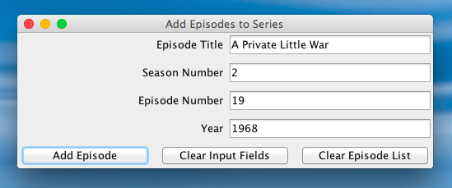
jtfTitle
jtfSeasonNumber
jtfEpisodeNumber
jtfYear
jtbAddEpisode
jtbClearInput
jtbClearEpisodes

lblTitle lblSeasonNumber lblEpisodeNumber lblYear

4. Review the source code for the SeriesDisplayWindow class, which is a class that presents a GUI window to the user to view a series and its associated episode list. Label each component of the GUI input window below with the corresponding code variables from SeriesDisplayWindow.

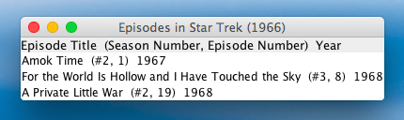
displayEpisodeList

5. Register each object that will serve as an ActionListener with its corresponding GUI input component. To determine which objects will serve as ActionsListeners, look for classes that implement ActionListener. To register an object as an ActionListener with its GUI component means that you need to “connect” the ActionListener objects to the objects that are listening for events. Do this by following the example shown in the code for AddEpisodeListener.
6. Add an actionPerformed() method to each class that serves as an ActionListener (the classes that implement the ActionListener interface). This method should handle the events specified in the source code of Driver.
7. Ensure that there are no warnings generated for your code. Do not suppress warnings. Fix your code so that warnings are not necessary. (If you can't figure out how to fix your code to avoid the cast warning on the cloned actionListenerList, you may leave in that warning.)
8. Submit this file (with completed answers) and the project archive following the steps given in the Submission Instructions by 4:00pm on 11 March 2016 through D2L (http://learn.ou.edu).

